

UiPath for RCM Automation

Miramed Global Services





Contents

1.1 Objectives 3

1.2 Process key contacts 3

1.3 Minimum Pre-requisites for automation 3

2. As IS process description 3

2.1 Process Overview 3

2.2 Applications used in the process 4

2.3 As IS Detailed Process map 5

3. To BE Process Description 6

3.1 TO BE Detailed Process Map 6

3.2 Detailed process steps: 6

3.3 Out of Scope for RPA 8

### Objectives

The business objectives and benefits expected by the Business Process Owner after automation of the selected business process are:

* *Reduce processing time per invoice*
* *Reduce the overall error rate*

### Process key contacts

The specifications document includes concise and complete requirements of the business process and it is built based on the inputs provided by the **process** **Subject Matter Expert (SME)/ Process Owner.**

The **Process Owner** is expected **to review it and provide signoff for accuracy** and completion of the steps, context, impact and complete set of process exceptions.

|  |  |  |  |
| --- | --- | --- | --- |
| *Role* | *Name* | *Contact details*  *(email, phone number)* | *Notes* |
|  |  |  |  |
|  |  |  |  |
|  |  |  |  |

### Minimum Pre-requisites for automation

1. Reference document for the process need to be deliver
2. Shortcut keys for navigation and process
3. Credentials (user ID and password) required to logon to machines and applications
4. Test Data to support development.

## As IS process description

### Process Overview

General information about the process selected for RPA prior to automation.

|  |  |  |
| --- | --- | --- |
| # | Item | Description |
| 1 | **Process full name** | *Envision AR* |
| 2 | **Process Area** | *Medical code* |
| 3 | **Department** | *Health Care* |
| 4 | **Process short description**  (operation, activity, outcome) |  |
| 5 | **Role(s) required for performing the process** |  |
| 6 | **Process schedule and frequency** |  |
| 7 | **# of items processes /month** | *5000 medical denial code* |
| 8 | **Average handling time per item** | *7- 10 minutes* |
| 9 | **Peak period (s)** | *End of month usually from 20th to 28th day of each month* |
| 10 | **Total # of FTEs supporting this activity** | *16* |
| 11 | **Level of exception rate** |  |
| 12 | **Input data** | *Excel data received from customer* |
| 13 | **Output data** |  |
| 14 | **System/Application Dependencies** | *Embillz application ,IDM view,IDG Application,A3 Excel* |

### Applications used in the process

The table includes a comprehensive list all the applications that are used as part of the process automated, at various steps in the flow.

|  |  |  |  |  |  |  |
| --- | --- | --- | --- | --- | --- | --- |
| # | Application name & version | System  Language | Login Module | Interface | Environment/  Access method | Comments  (Include URLs) |
| 1 | *Embillz application* | EN | Production | Client | Application |  |
| 2 | *IDM view* | EN | Production | Client | Application |  |
| 3 | *,IDG Application* | EN | Production | Client | Application | m |
| 4 | *A3 Excel* | EN | Production | Client | Application |  |

### As IS Detailed Process map

This chapter depicts the AS IS business process in detail to enable the developer to build the automatedprocess.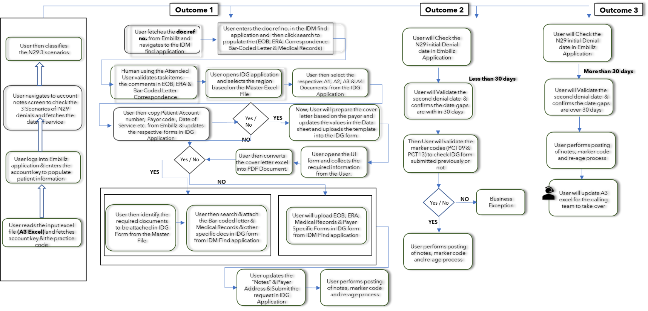

|  |  |  |
| --- | --- | --- |
| step | **Short Description of Key Process Steps** | **AVG**  **TAT in mins** |
| ***1*** | Check e-mail and download attachments from outlook | 1 |
| ***2*** |  |  |
| ***3*** |  |  |
| ***4*** |  |  |
| ***5*** |  |  |

## To BE Process Description

This chapter highlights the expected design of the business process after automation.

### TO BE Detailed Process Map

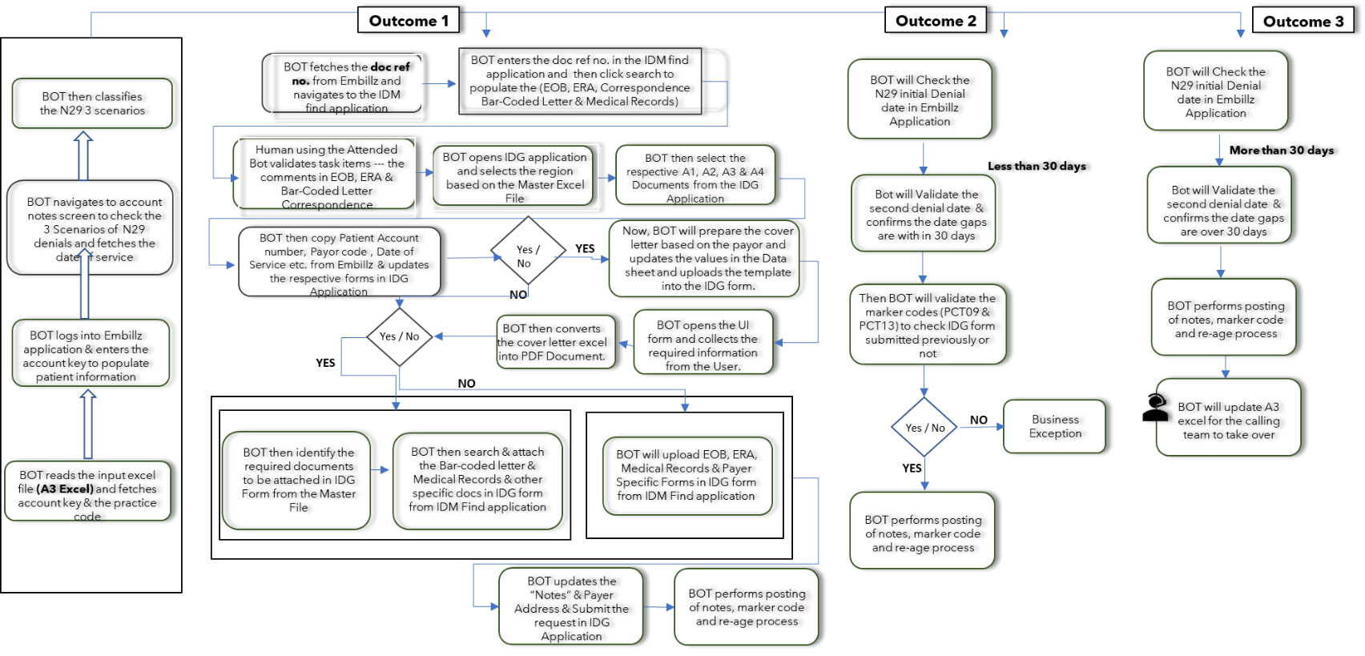

### Detailed process steps:

The Steps of Denial process, are listed here:

* *Fetching the patient Information from excel(Account Key).*
* *Opening Embillz application by entering login credentials.*
* *Resetting practice.*
* *Entering the patient account key in Embillz application.*
* *User navigates to Account Notes screen and validates the occurrences of N29 Denial code present in the notes list.*
* *Then User performs further process based on the scenario*
* *If the occurrence of N29 is one, then User fetches the Doc Ref No from the Embillz Application, and the value is incremented by 1.*
* *Then, User enters the value in the IDM View application (Document Number Field).*
* *List of documents are displayed, and User selects the appropriate document.*
* *Human using the Attended User validates task items --- the comments in EOB, ERA & Bar-Coded Letter Correspondence*
* *Once Document validation is completed, User opens the IDG Application and selects printed document based on the state and region. According to this the AR Document is displayed.*
* *User enters the required fields in the AR Document (Patient Account Number, Patient Name, Claim Code, DOS, Vendor Name as MiraMed, Reason for Request as ‘Payer Requested Information’, Other as ‘Request Medical Record’)*
* *If Medical record only requested, User navigates to the path where the template excel is present and opens the excel and updates the data. User then opens the Ui Form to collect the key information from the document which will be performed by the user (Human in the Loop).*
* *If Barcoded document is present, then User uploads barcoded document and medical record along with from the scanned image folder.*
* *If Barcoded document is not present, then User uploads EOB/ERA document and complete medical record.*
* *Once document upload is completed, User enters the Address and Notes information from the document(Attended Extraction) in the required fields and submits the IDG Request.*
* *User then performs the process of notes posting, marker code and reage the account.*
* *If the occurrence of N29 Denial code is two, then User validates the date frame difference between the two dates and if the difference is less than 30, then User navigates to Account Notes screen and fetches first N29 Denial Doc Ref no and navigates to IDM View application.*
* *User selects Find Document type as RTI Post Billing Documents and enters the Doc Ref no in the Document Number and selects the appropriate document from the list of documents.*
* *Once Document validation is completed, User then validates the marker code to check whether IDG form was previously submitted or not.*
* *If IDG form was submitted previously, User then performs the process of notes posting, marker code and reage the account. And if not, then Business Exception is raised.*
* *If the occurrence of N29 Denial code is two or more, then User validates the date frame difference between the two dates and if the difference is more than 30, then User opens IDG Application to check for the availability of medical records.*
* *Once Document validation is completed, User performs the process of notes posting, marker code and reage the account.*
* *Now, User opens the A3 Excel Application and selects the candidate’s comment from the list based on account key & practice code.*
* *Now ,User selects the Add notes option and enter the prepared notes into the field & clicks save* *Once the scenario is completed, User starts to perform notes posting, marker code and reaging the account.*
* *User navigates to Viewer Action Mode by hotkey operation (F7 key) and navigates back to the input excel to copy the notes.*
* *Then User switches back to the Viewer Action Mode screen and opens Construct Message to Paste screen through hotkey operation and paste the notes into the screen and completes the notes posting process.*
* *Then User navigates back to the Menu option screen and selects New Batch Process and Addition Reports using shortcut key and User navigates to Payment Approval screen by selecting Payment Approval option.*
* *User enters the required fields (Payment variant & Post Doc#) and navigates to excel spreadsheet and copies the payor code and navigates back to the Embillz application and enter the value into PYR field.*
* *User navigates back to the excel spreadsheet and copies the marker code and navigates back to the Embillz and paste the value into the RMT field and by submitting completes the marker code process.*
* *User then navigates back to the Menu option screen and selects Inquiry Master Tables and User selects batch type as M7 FLEX/Mail –A/R (11).*
* *User then selects payor to create new batch through shortcut key (‘T’) in the function section.*
* *Once the batch screen appears, User enters the required fields (Global Transfer as Y, Forces assignment as N and the details as required like Global Transfer Details From value as OldPayor details & To value as NewPayor details, PR bill as N, Resets Aging as Y) and completes the reaging process for the account.*

### Out of Scope for RPA

The activities **OUT of scope of RPA**, are listed here. Mention of the changes/ improvement opportunities identified for automation are out of scope for this automation iteration.

### *Any process, business rule or validation not covered under the scope*

### *Any additional features or customizations requested beyond agreed scope & design*

### *Any handling of additional data sources, apart from Embillz application ,IDM view,IDG Application,A3 Excel*